**Inventory: Missing pieces**

Copy of Inscriptions of Burma မြန်မာတိုင်းရင်းကျောက်စာများ 5 volumes = *IB*

*Check on diameters and other measurements of urns and other inscriptions?*

*(016) socle of stone Buddha image*

Ray, Nihar-ranjan, Sanskrit Buddhism in Burma, Amsterdam: H.J. Paris. 1936.

John Guy, A warrior-ruler stele from Śrī Kṣetra, Pyu, Burma. Journal of the Siam Society. Vol 85, issue 1/2 , 1997.

*(027) Bottom of urn*

We need clear photos – and ultimately, a rubbing; the RTI scans are not good.

*(034) Clay seal fragment*

Sheila Hoey Middleton, Intaglios, cameos, rings and related objects from Burma and Java. BAR international series. Oxford: Archeaopress. 2005. We have relevant excerpts.

*(035) Relief sculpture*

Aung Thaw, Historical sites in Burma. Rangoon: Ministry of Union Culture, Government of the Union of Burma. 1972.

*(036) metal sculpture of preaching Buddha*

Presence of inscription not yet noted when catalogue entry was written for Guy 2014. Photographed in 2012 at the National Museum in Yangon by museum staff.   We need better photos of the inscription on the back.

*(037) Bronze statue*

Sein Win, Mranmā nuiṅ ṅaṃ samuiṅḥ atvak athok akū pru so pyū kreḥ chaṅḥ tu tac chū [A Pyu Bronze Useful for the History of Myanma], 1997

Donald Stadtner and Michael Freeman, Ancient Pagan: Buddhist plain of merit. Bangkok: River Books. 2007

Naing Zaw, Pyū nuiṅ ṅaṃ tau nhaṅ. pyū nuiṅ ṅaṃ sāḥ myāḥ [Pyu Civilization: The Regions and Peoples], Yangon: Sīrivaccha. 2011. (also 067)

(Note contact information: Khin Zaw (penname Naing Zaw) Srivasta (Thiri-witsa) Publications, No. 99/4 Nawarat Estate, U Wisara Rd, Dagon Tsp., Yangon 11191, Ph: 095 095007074, E: [prof.naingzaw@gmail.com](mailto:prof.naingzaw@gmail.com), URL: [http://profnaingzaw.com](http://profnaingzaw.com/), Linkedin: <https://www.linkedin.com/in/khin-zaw-12791254>)

Yinkyayhmu sasaung [Culture Bulletin]. Nay Pyi Taw: Government of Myanmar Ministry of Culture. 2005

*(038) Silver bowl - lid*

Myint Aung, The spread of Halin culture. Working People’s Daily, 31 August 1978

Sein Maung Oo. Mongmao: a forgotten city. Working People’s Daily, 21/23 January and 3 February 1981

*(040) metal sculpture of preaching Buddha*

Maung Maung Swe, Study of the Morphological Features of Ancient Scripts Found in Konseit Pali Stone Inscription. Universities Research Journal, vol. 4, issue 6, pages 1-12, 2011.

*(041) stone stele (063) clay sealing*

Aung Thaw, “New light on Pyu culture”, Union of Burma Journal of Literary and Social Sciences, Research development and co-ordination committee, Vol. 1, No.1, Rangoon, January 1968, pp 49-59. Cited by Skilling in 1997b.

*(045) Khin Ba gold leaves*

Than Hswe [Sanḥ Chve]. 1991. *Pyū cā khaṅ bha rhve pe khyap dhāt puṃ myāḥ [Photographs of the Pyū Text of the Khin Bha Gold Plates]*. Yangon: Myanmar Literature Association.

———. 1992. *Pyū cā khaṅ bha rhve pe khyap le. lā khyak. [A Study of the Pyu Writing on the Khin Ba Gold Leaves]*. 2 vols. Yangon: Myanmar Literature Association.

*(059) fragments of a stone slab (?)*

D. C. Sircar, Indological notes. 21: R.C. Majumdar's Chronology of the Pāla kings. 22: Two inscriptions from Prome and Vesali in Burma. Journal of ancient Indian history, vol 9, 1976.

Pamela Gutman = The Martaban Trade: An Examination of the Literature from the Seventh Century until the Eighteenth Century (no access). Asian Perspectives, 40.1, 2001.

*White intaglio (106)*

Myint Aung, The Excavations at Halin, JBRS 53.2, 1970

NOTES

*Is “White” under entries such as Agate ringstone (104) a bibliographic entry? Is so, which?*

*Add Moore 2007 = Early Landscapes to Zotero.*

To check at Prome?

*> Is there now a small museum with Pyu things at the University of Pyay ... I heard that some thing went there but when I was there ... there was some political problem going on ... and the gendarmerie had blocked all entrances to the campus ... so I was left wondering … AG> I saw no inscriptions in the Pyay library, apart from these on a few bricks and on votive tablets ... there are 2 spectacular terracotta heads in the library from S.K …*

*I have a record of an inscribed silver bowl which would be at the Shwe Phon Pwint Library & Museum, Pyay, if my record is not mistaken. Am unable to trace a photo that I should have.*

Khyac Caṃ Vaṅḥ [Chit San Win], Pyū. Yangon, Panḥ myuiḥ tac rā, 2011.

Study on Pagan, research report?

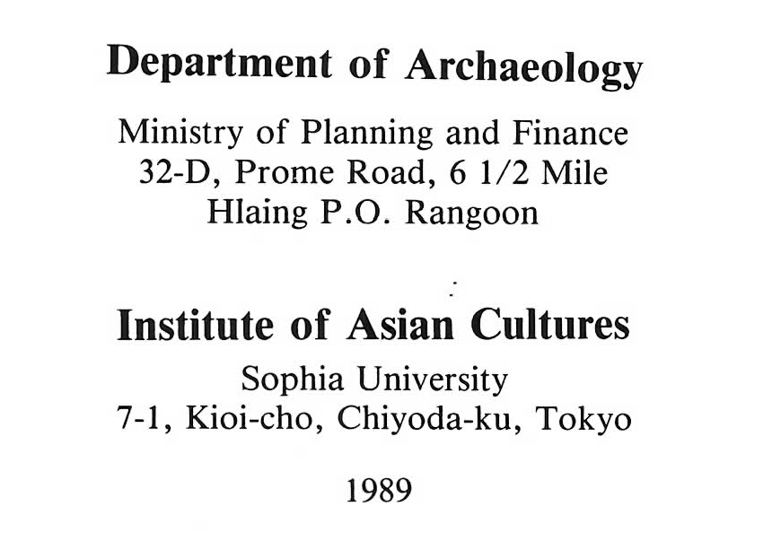 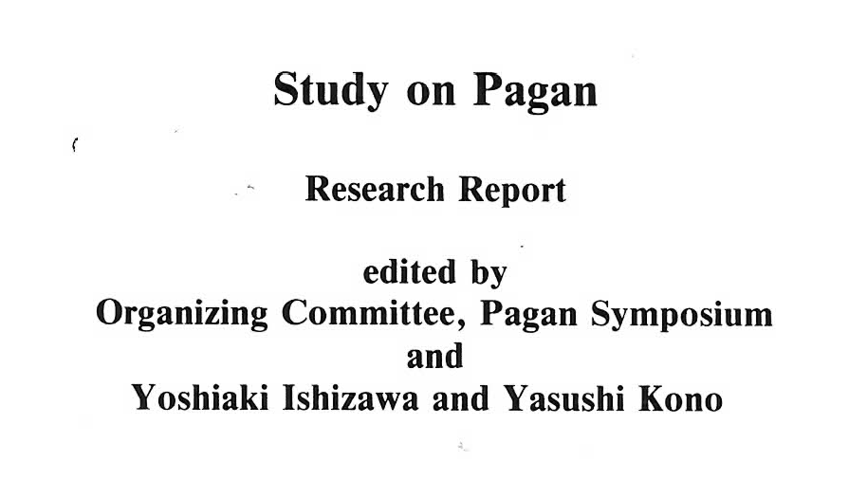

<http://www.myanmarbookshop.com/MyanmarBooks/BookDetails/21475>.